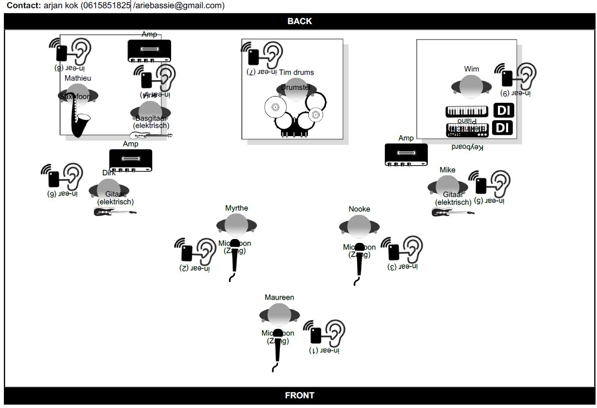
This is TINA stageplan 2024/25
MAUREEN LEADVOCALS DIRK RHYTHM GUITAR, STAGE RGHT
NOOKE BACKING VOCAL 1 MATHIEU SAXOPHONE, STAGE RIGHT
MYRTHE BACKING VOCAL 2 WIM KEYBOARD,STAGE LEFT
TIM DRUMS ARIE BASSGUITAR, STAGE RIGHT
MIKE LEADGUITAR, STAGE LEFT

IMPORTANT NOTES:
LEAD AND BACKING VOCALS WIRELESS MICROPHONES MANDATORY
DRUMRISER MINIMUM 200 X 200 MTR – MINIMUM 50 CM HIGH
KEYBOARD RISER MINIMUM 200 X 200 MTR – MINIMUM 30 CM HIGH
SAXOPHONE/BASSGUITAR RISER MINIMUM 200 X 200 MTR – MINIMUM 30 CM HIGH

INEAR SYSTEMS- MIX NOTIFICATIONS:
WE HAVE OUR OWN IN EARRACK and our own IN-EAR SYSTEMS (BELTPACK/TRANSMITTER)

CHANNELLIST IN EXCELL.
PLEASE USE FOLLOWING ORDER ACCORDING TO CHANNEL LIST.

